Phishing Email Analysis Report

Objective
The purpose of this report is to analyze a suspected phishing email sample, identify common phishing indicators, classify the associated risk level, and provide cybersecurity awareness guidance for users and employees.
1. Email Sample Overview
Email Details
- Sender: manager@securemygataway.com
- Subject: “Urgent Transfer of Funds Required”
- Claimed Organization: Outlook Support Team
- Main Message: Account verification required to avoid account suspension
Initial Observation
The email contains several suspicious characteristics commonly associated with phishing attacks, including urgency, impersonation of a trusted organization, and requests related to account verification. These tactics are frequently used by attackers to trick users into revealing sensitive information or performing unauthorized actions.
2. Phishing Indicators Identified
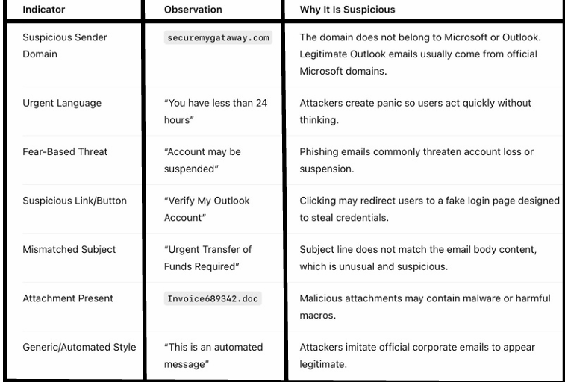

3. Risk Classification
Classification: HIGH RISK — PHISHING EMAIL
Reason
This email contains multiple strong indicators commonly associated with phishing attacks, including:
- Fake or suspicious sender domain
- Urgency and fear-based language
- Suspicious account verification request
- Possible credential theft attempt
- Potentially malicious attachment or link
- Fake impersonation of Outlook/Microsoft support
Based on these indicators, the email is highly likely designed to steal user credentials, sensitive information, or infect the victim’s device with malware.
4. How the Attack Works
This phishing attack attempts to trick the victim into believing that their Outlook account will be suspended unless immediate action is taken.
Attack Flow
- The attacker sends a fraudulent email pretending to be from Outlook Support.
- The email creates urgency by threatening account suspension.
- The victim is encouraged to click a fake verification or login link.
- The victim may unknowingly enter credentials on a malicious website.
- Attackers capture usernames and passwords or distribute malware through attachments or downloads.
This technique relies on social engineering to manipulate users into taking actions without carefully verifying the legitimacy of the message.
5. Technical Analysis
Sender Domain Analysis
- Claimed Sender: manager@securemygataway.com
Official Outlook or Microsoft-related emails typically use trusted domains such as:
- microsoft.com
- outlook.com
- office.com
The sender domain used in this email is unrelated to Microsoft or Outlook services, strongly indicating spoofing, impersonation, or phishing activity. This mismatch between the claimed organization and the actual sender domain is a major phishing indicator.
Attachment Analysis
File Detected
Invoice689342.doc
Risk Analysis
The attachment uses a Microsoft Word (.doc) file format, which can potentially contain malicious content. Attackers commonly use document files in phishing emails to deliver malware or compromise systems.
Potential risks associated with such attachments include:
- Malicious macros
- Embedded malware
- Trojan downloaders
- Credential-stealing programs
- Remote access malware
Security Observation
Opening attachments from unknown or suspicious senders may compromise the device and allow attackers to gain unauthorized access to sensitive information or install malicious software.
Users should avoid opening unexpected attachments and should verify the legitimacy of the sender before downloading or enabling document content such as macros.
Social Engineering Techniques Used
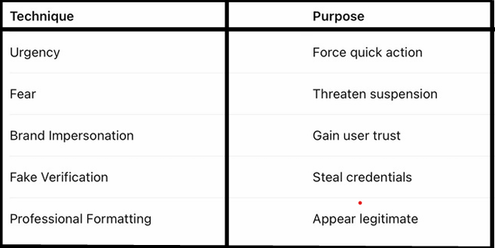
6. Impact if the User Falls for the Attack
If the victim interacts with the phishing email or provides sensitive information, the following consequences may occur:
- Theft of Outlook or Microsoft account credentials
- Unauthorized access to personal or business accounts
- Financial fraud or unauthorized transactions
- Malware or ransomware infection
- Theft of confidential or sensitive data
- Business Email Compromise (BEC) attacks
- Identity theft and misuse of personal information
These attacks may affect both individual users and organizations, leading to financial loss, operational disruption, and reputational damage.

7. Prevention & Awareness Guidelines
Do’s
✔ Verify sender email domains carefully before responding.
✔ Hover over links to inspect URLs before clicking.
✔ Enable Multi-Factor Authentication (MFA) for account security.
✔ Report suspicious emails to IT or cybersecurity teams immediately.
✔ Keep antivirus software, operating systems, and applications updated.
✔ Confirm urgent or sensitive requests through official communication channels.
Don’ts
✘ Do not click suspicious or unknown links.
✘ Do not open attachments from untrusted senders.
✘ Do not share passwords or sensitive information through email.
✘ Do not immediately trust urgent threats or pressure tactics.
✘ Do not enter login credentials on unfamiliar or suspicious websites.

8. User Awareness Tips
Employees and users should remember the following cybersecurity practices:
- Legitimate companies rarely threaten immediate account suspension through email messages.
- Official services typically address users using their real names rather than generic greetings.
- Always independently verify suspicious emails before taking action.
- If unsure, contact the organization directly through its official website or verified support channels.
- Be cautious of emails that create panic, urgency, or request confidential information unexpectedly.
Example of a Phishing Attack Email
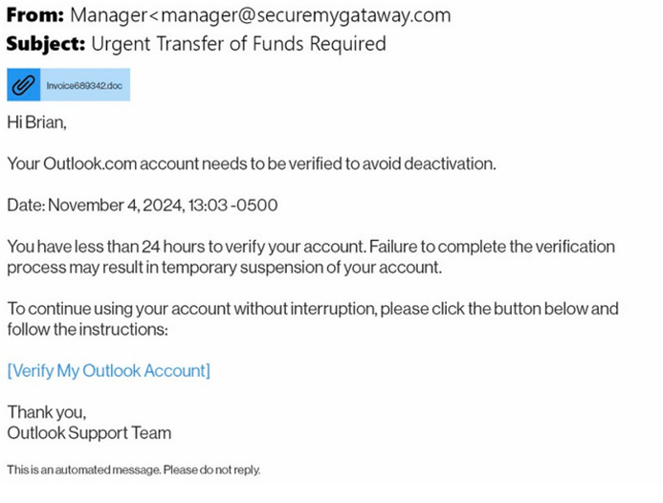
9. Final Conclusion
The analyzed email is a clear phishing attempt designed to impersonate Outlook Support and deceive users into revealing account credentials or downloading malicious files.
The phishing email demonstrates several common attack techniques, including:
- Fake or suspicious sender domains
- Urgency and pressure tactics
- Fear-based messaging related to account suspension
- Suspicious attachments
- Fraudulent account verification requests
These indicators strongly suggest an attempt to steal sensitive information, compromise user accounts, or infect systems with malware.
Users should avoid clicking links, opening attachments, or responding to the email. The message should be reported immediately to the appropriate IT or cybersecurity team for further investigation and mitigation.

